**INRODUCTION:**

* We Are Four Members in A Crew,

Team Lead: ARCHANA B L

Team Member 1: MOUNICA M

Team Member 2: GNANESHWARI L

Team Member 3: HEMALATHA L

**PROJECT TITLE:**

* BUILD EVENT MANAGEMENT SYSTEM USING SALESFORCE

**PROJECT DESCRIPTION:**

* Event Management is a Process of Organizing a Professional and focused event for a particular target audience. It involves Visualizing concept Planning, Budgeting, organizing and Executing Events Such as wedding, Musical Concerts corporate Seminar, Exhibition Birthday Celebrations, Theme Parties.

**DONE PROJECTS:**

* We Have Done Empathy Map and Ideation & Brainstorming Map,
* We Have Eight Milestone Projects and We Have Done This Projects.

**PURPOSE:**

* An Event Management System Helps Organizer Plan, Execute and Report on Events, Driving Success for Their Business.

**PROBLEM DEFINITION & DESIGN THINKING:**

* **EMPATHY MAP:**

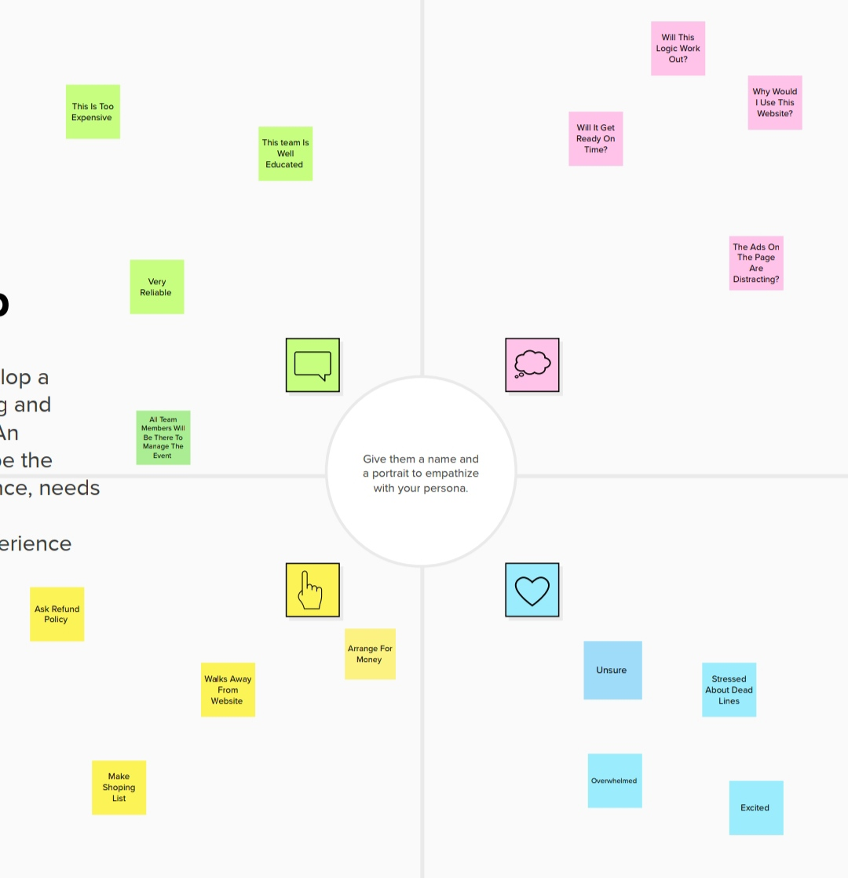

**IDEATION & BRAINSTROMING MAP:**

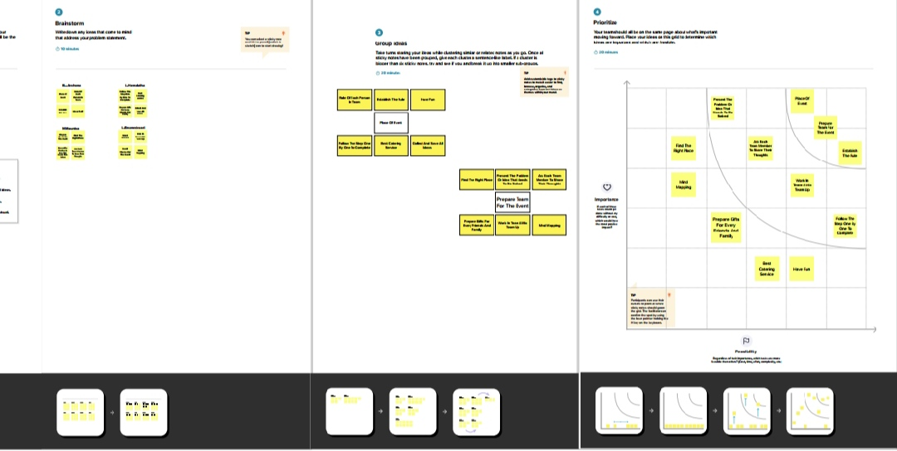

**RESULT:**

**DATA MODEL:**

|  |  |  |  |  |  |
| --- | --- | --- | --- | --- | --- |
| **OBJECT NAME** | **FIELDS IN THE OBJECT** | | |  | |
|  |  | | |  | |
| **OBJECT 1** | **FIELD LABLE** | | | | **DATA TYPE** |
| **SPEAKER** | blarchana@gmail.com | | | | Email |
| **VENDOR** | 9500284904 | | | | Phone |
| **OBJECT 2** | **FIELD LABLE** | **DATA TYPE** | | | |
| **ATTENDEE** | 01052003 | Auto Number | | | |
| **EVENT** | 05/04/2003 | | Date/Time | | |

**ACTIVITY & SCREENSHOT:**

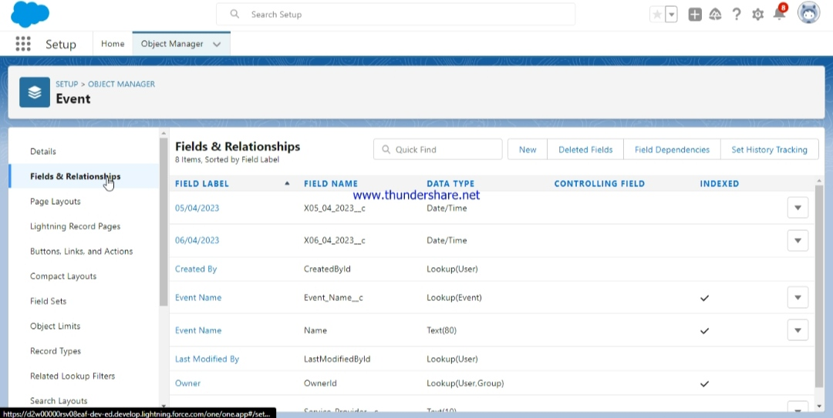

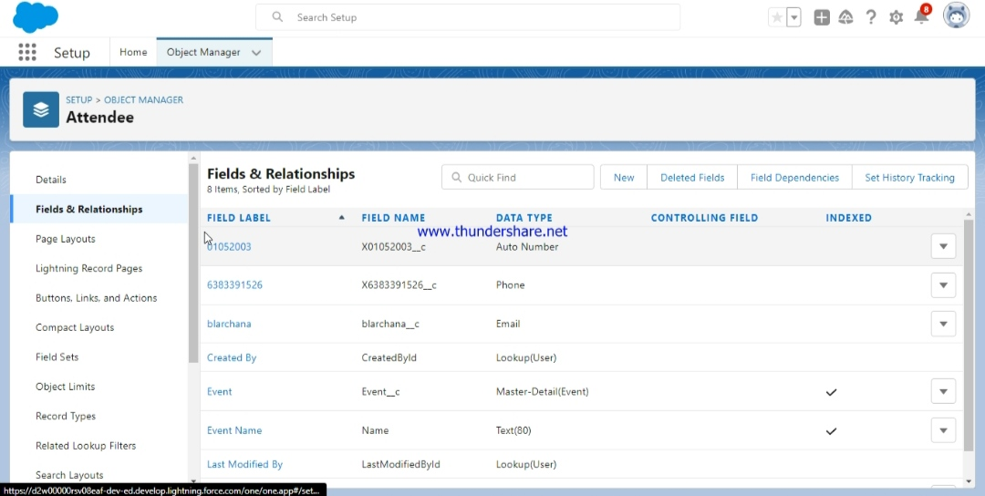

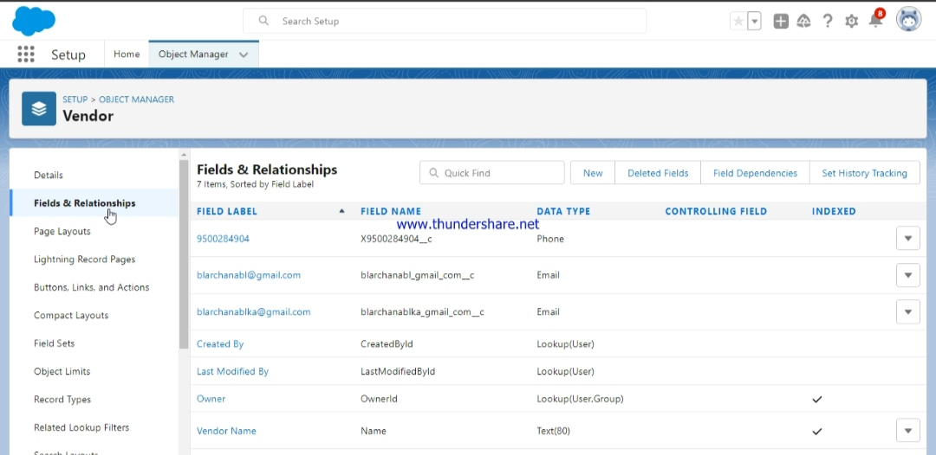

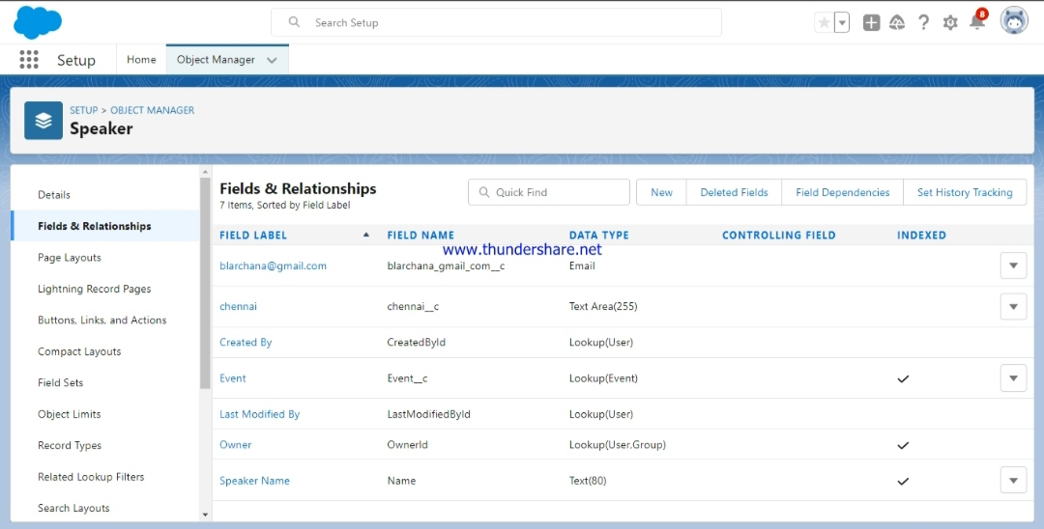

**TRAILHEAD PROFILE PUBLIC URL:**

**TEAM LEAD-** <https://trailblazer.me/id/parchanabl>

**TEAM MEMBER 1:** <https://trailblazer.me/id/phemalathal>

**TEAM MEMBER 2:** <http://trailblazer.me/id/pmounicam>

**TEAM MEMBER 3:** <http://trailblazer.me/id/pgnaneshwaril>

**ADVANTAGES & DISADVANTAGE:**

* Reduces Uncertainty
* Focus on Objectives / Goals
* Economic Control
* Improves Motivation

**DISADVANTAGE:**

* Lack Of Reliable date
* Rigidity
* Time consuming Process
* Costly Process

**APPLICATIONS:**

* Cultural Events and Celebrations
* Arts and Entertainment Events
* Business and Trade Events
* Sports Events
* Educational and Scientific Events
* Political and State Events

**COUNCLUSION:**

* Event Management System is User Friendly and Cost effectives related to event Management Life-cycle. It Provides a new edge to Management Industry. Solution dot always keep Your Objectives and goals on yy

**FUTURE SCOPE:**

* The Scope of Event Management as a Career in India is Vast. Its a Thriving Industry and is Home to a Million People. So, if you have a Knack for Creativity and Want to Redesign the Perceptions of Society, The Event Management Industry is all for you.

**THANK YOU!**